Diocese of Jamaica and the Cayman Islands

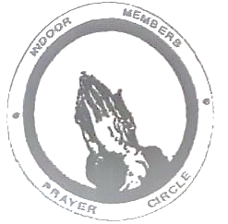

Indoor Members Prayer Circle
June - August 2023
God spoke: “Let us make human beings in our image, make them reflecting our nature so they can be responsible for the fish in the sea, the birds in the air, the cattle, And, yes, Earth itself, and every animal that moves on the face of Earth.” God created human beings; He created them godlike, Reflecting God’s nature. He created them male and female. God blessed them: “Prosper! Reproduce! Fill Earth! Take charge! Be responsible for fish in the sea and birds in the air, for every living thing that moves on the face of Earth.”
Genesis 1: 26 - 28
Dear Friends,
As summer rolls in our thoughts turn to hurricanes. Are you ready for the hurricane season? There are predictions of stronger storms. Make sure you stock up on non-perishable food & water – about 3 weeks worth. Where possible try to have medication on hand also. Wrap documents in plastic, check windows, doors, overhanging trees. If in low lying areas, determine your nearest shelter and an escape route.
We can’t predict when an earthquake may occur but take what precautions you can. Put away items likely to topple and cause injury. Identify where you can take cover during the earthquake. Make friends with your neighbours. They may be your main support following a disaster.
Our exploitation of our environment has been blamed for many of our challenges with our habitats. We were invited by our Creator God to take responsibility for his creation yet the greedy have made life difficult for the needy. We have been careless with our garbage, not thinking of those creatures we consider lower than we are. We hear of species becoming extinct, does that mean anything to you? Is it “someone else’s problem”? June 4 – 10 is Environmental Awareness Week. Challenge yourself to learn something about your environment and select one action to make your area cleaner and safer.
In this issue, you are introduced to Prayer Squares. Ask your Branch President to share the pattern for these squares if you are interested in making one. We thank Fr. M. Elliot for the meditation on Transfiguration (August). Make a popsicle and share with your grandchildren or neighbour’s children. Have one yourself. Hydrate! Rest! Shalom
Prayer Square Ministry: June
This is also known as a Prayer Square, Prayer Quilt or Prayer Shawl Ministry. The one thing that they all have in common is that they are given to persons who are shut ins, or unable to attend regular church services. The prayers and squares combine the gift of prayer which minister to the receiver. The purpose of the Prayer Squares is not to make and distribute items, but to promote prayer through the use of squares.
The idea behind this form of ministry is quite simple. A thread is used to take stitches through the item and the ends are left free to be tied with a square knot. As each knot is tied, a silent prayer is offered for the person in need. The item is then given to that person. What makes each item unique is not the pattern, colour or workmanship, but the fact that a prayer is symbolically tied into each item. These prayer tokens are a statement of faith, and a testimony to our belief in God and in the power of prayer.
For me, the Prayer Square is a way for me to do a quiet ministry. This is something that I can do during my quiet moments, whether I am watching tv or listening to an audio book, having lunch etc. It brings joy to those who receive it and tells them that someone is thinking about them and praying for them.
Once finished, I place it in a card, along with a prayer and a short note. The card with the square is placed inside an envelope and given to the person.
For instructions on how to make the square, ask your Branch President. Instructions will be placed in the Branch Presidents WhatsApp group.
DJCI Wave of Prayer: June
- May 28 - June 2: Deanery of Manchester
- June 3 – 9: Deanery of Portmore
- June 10 – 16: Deanery of Westmoreland
June 19: Fathers’ Day
- June 17 – 23: Link Dioceses/Branches
- June 18 – 20: Wave of Prayer
- June 24 – 30: Deanery of St. Mary

DJCI Wave of Prayer: July
- July 1 – 7: Deanery of Clarendon
- July 8 – 14: Deanery of St. Ann
- July 15 – 21: Deanery of St. Thomas
- July 22 – 28: Deanery of Trelawny
- July 29 - August 4: Deanery of Portland

DJCI Wave of Prayer: August
- July 29 - August 4: Deanery of Portland
- August 5 – 11: Deanery of St. Elizabeth
- August 9: Mary Sumner Day
- August 12 – 18: Deanery of St. Andrew
- August 19 – 25: Deanery of St. Catherine
- August 26 - September 1: Diocesan
- Committee and Staff at MU Office

Fruit popsicles
What you will need:
Fruits, coconut milk, orange juice, honey.
How to prepare:
- Cut two cups of mango, add one cup coconut milk, one and a half tablespoons of orange juice, and one and a half tablespoons of honey.
- Blend all the ingredients, then put into ice trays/popsicle moulds. Cover tray with plastic wrap, then stick popsicle sticks into each section and freeze overnight.

Climate Change: July
Climate change refers to long-term shifts in temperatures and weather conditions over decades or longer. It is the longer-term trend that differentiates climate change from natural weather variability. Signs of climate change- intense rain and more floods, more frequent and severe heat waves, droughts, oceans are warming and becoming more acidic, ice caps are melting, and sea level is rising. Evidence shows that the current warming cannot be explained by the Sun but have been linked to the actions of human beings. Burning fossil fuels, cutting down forests and farming livestock are increasingly influencing the climate and the earth's temperature. These significantly increase the greenhouse effect and global warming.
While we cannot stop global warming overnight, we can slow the rate and reduce human emissions of heat-trapping gases and soot.
Ten Simple Things You Can Do to Help Protect the Earth
- Reduce, reuse, and recycle. Cut down on what you throw away.
- Volunteer for clean-ups in your community.
- Educate family and friends on how to slow climate change
- Conserve water.
- Choose sustainable/reusables.
- Shop wisely. Buy what you need.
- Use long-lasting light bulbs.
- Plant a tree
- Don't send chemicals into our waterways. Choose non-toxic chemicals in the home and office.
- Drive less. Walk where you can

The Transfiguration: August
Luke 9 v 35 ‘Then from the cloud came a voice that said, “This is my Son, my Chosen; listen to him!”’

Many of us want to hear from God; we want some direction for our lives, we want some intervention in many situations in our lives. In the Transfiguration, God invites us to listen in on Jesus’ conversation with Moses and Elijah. What were they talking about? Luke says, Jesus’ departure . . . Jesus’ impending death. Additionally, with Jesus’ exodus he was rescuing us, God’s people, out of slavery by releasing us from all those things that have an unholy hold on us – immorality, love of money, lust for power and death. The Gospels speak of a God who protects His people from their enemies, the anxieties of life and whatever else separates us from God. These things are ‘drowned’ in the waters of our baptism even as God brings us safely to the other side, leading us by the ‘cloud’ of His Grace and the ‘fire’ of His Spirit.
So which voice are we listening to? Which voice is the Church really listening to? In the midst of all life’s vagaries, have we put ourselves in a position to hear God’s voice, to wait on Him, to receive His instructions? And are we ready to act!

Listen to Jesus, God says. We will hear Him saying that He will be with us in the wildernesses of the world and in all the exits and exoduses of our lives. He says come to Me in sincere, humble prayer, and wait and trust in Me. He challenges us to be willing to address our situations God’s way. He challenges us to listen to Him! Shhhhhhh.

Upcoming Events
- June 4: Trinity Sunday
- June 12t: St. Barnabas, Apostle
- June 18 – 20: Wave of Prayer
- June 24: Nativity of John the Baptist
- June 29: St. Peter & St. Paul
- July 22: St. Mary Magdalene
- July 25: St. James the Apostle
- August 1: Emancipation Day
- August 6: Transfiguration of the Lord
Independence Day (Jamaica)
- August 15: St. Mary the Virgin
- August 24: St. Bartholomew

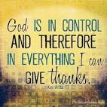

Pray for:
- Children going back to school
- Parents who are anxious
- Children who are stressed out – mental challenges, confused
- Unsafe homes – parents not being parents, financial challenges, unsafe buildings
- Settling of industrial challenges locally and internationally.
- Safe fun for persons on vacation, may they be rejuvenated
- All travelling by land, air and sea
- Those called on to share their faith that they may do so boldly, allowing God to give them the words.
- More members to attend Bible Study

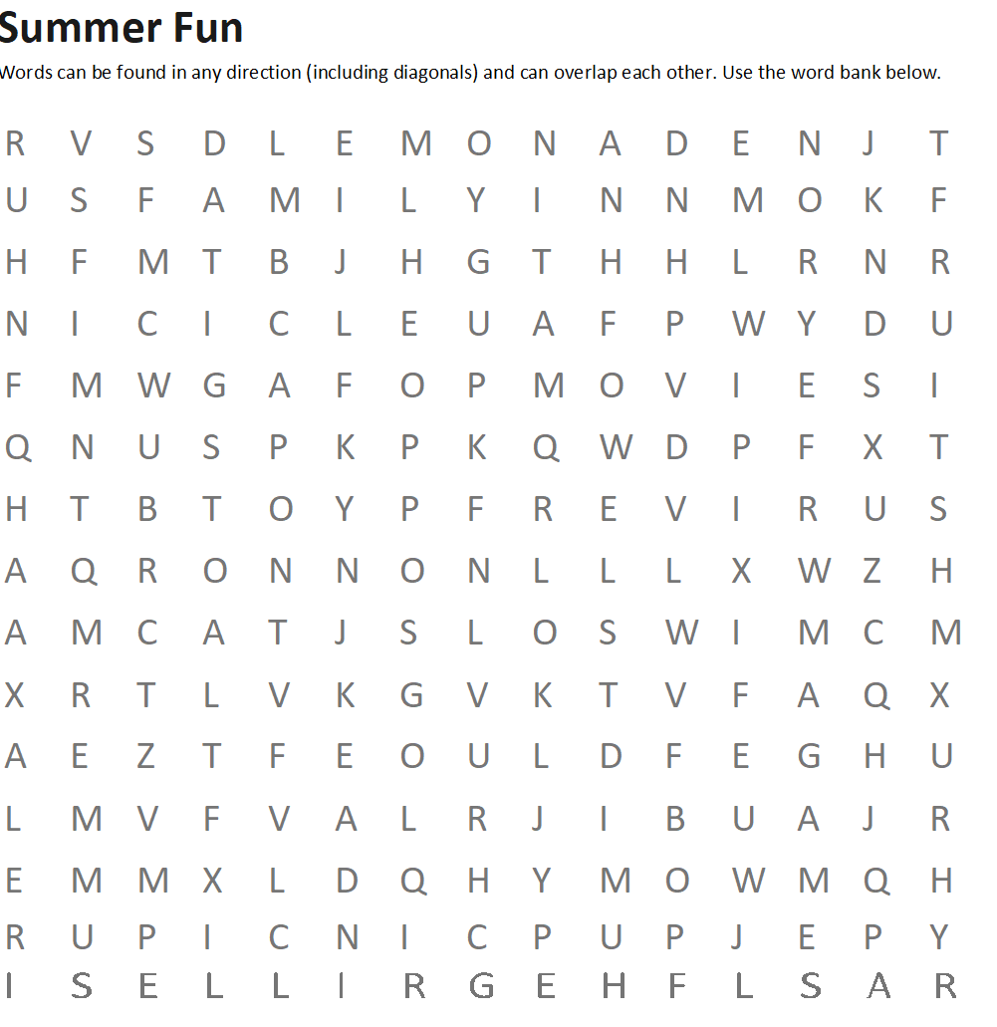

Beach Happy Relax
Cookout Humid River
Family Icicle Summer
Fruits Lemonade Sun
Games Movies Swim
Grill Picnic Travel

Let’s Hear from You
Is there anything you want featured? Do you have a poem or song to share? Send your questions, comments, contributions to us using one of the following methods:
WhatsApp: 876-865-6570
Email: munion@anglicandiocese.com

